***Best Wishes for Success***

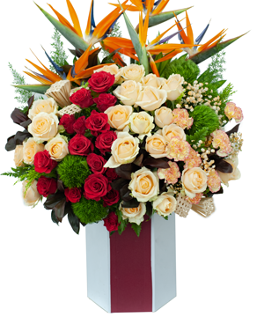

*"Red roses combined with lotus roses, and auspicious stones are planted in a circle, symbolizing success, fullness, and abundance in career and life. Accompanied by orchid branches reaching up to symbolize success. The flower pattern is a wish of success suitable for friends, relatives, customers on the occasion of birthday, grand opening, anniversary.*